**Game Rules**

The game is for 4-6 players.

Set-up:

Depending on the amount of people playing, you will always need 2 liar cards and enough truth cards so that every player will have a card. (E.g. If there are 6 players, you will need 2 liar cards and 4 truth cards).

Players will need 2 voting tokens each and a player number card placed in front of them.

The question cards will need to be placed in the centre, separated into the different categories. The betting board will also need to be placed in the centre.

Gameplay:

At the start of each round the truth/liar cards must be shuffled and handed out face down to each player.

The players must look at their card in secret to determine whether they will be lying or telling the truth that round (there will only be two liars each round) and must not tell the other players what is written on their card.

Players may take it in turns by player number to select a question category each round. A card from the top of that pile will be turned over and placed in the centre for all players to see. This is the question all players will need to answer that round.

After time has been given for the players to think about their answer to the question, players must each give their answer to this question one by one. If you received a truth card at the start of that round, your answer to the question must be truthful but if you received a liar card you must give an answer which isn’t true.

After each player has stated their answer, players have a chance to discuss who they think might be lying and will have the opportunity to ask questions to further investigate people’s answers.

After everyone has had a chance to ask their questions and discuss who they think might be lying, players must vote for who they think is lying by placing tokens on the betting board in the centre.

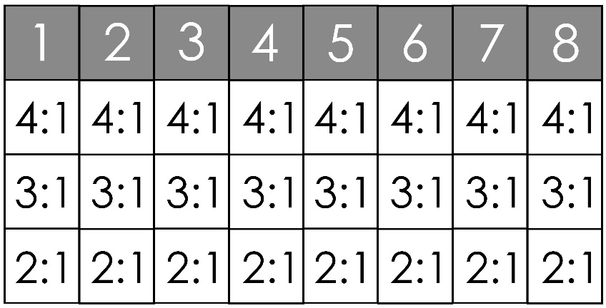

You can bet tokens on as many players as you like and can place as many tokens on one person as you like. To vote, place your tokens under the number corresponding to the player(s) you want to vote for. If you are the first person to bet on a player, place your tokens in the first slot under their number, if you are the second person to bet on a player, place your tokens in the ‘3:1’ slot below their number and if you are third or later, place your tokens in the ‘2:1’ box.

Scoring:

* The box you place your tokens in corresponds to the amount of tokens you will gain for guessing correctly:
* If your tokens are in the 4:1 box, you will gain 4x the amount of tokens you placed on a player for a correct guess, if your tokens are in the 3:1 box, you will receive 3x the amount of tokens you placed and if your tokens are in the 2:1 box, you will gain 2x the amount you placed
* If you place tokens on a player who was telling the truth, you will lose all tokens placed on this player
* You will always keep 2 tokens, you can never run out of tokens

The game ends when each player has had a turn to choose a question card, the player with the most tokens at the end of the game wins.